
Prepared by: Kimia Sadat Karbasi
Student ID: 60393958
Email: kimia.karbasi@ue-germany.de
Course/No: Software Optimization – P1SO01
Subject: Implementation of DES in CFB Mode
Professor Name: Dr. Rand Kouatly
Example.No: Task4
Report on
Implementation of DES Using Python
(CFB Mode)

Introduction

The Data Encryption Standard (DES) is a symmetric-key block cipher, as it introduces fundamental concepts in block cipher design and modes of operation. This report presents a Python implementation of DES in Cipher Feedback (CFB) mode using the PyCryptodome cryptographic library.

Overview

This report provides a comprehensive analysis of a DES-CFB (Data Encryption Standard in Cipher Feedback mode) implementation and its integration with OpenSSL, presented through four systematic phases
- Encryption Data: Initialization, Input Handling, Key Management, IV creation, Cipher Configuration, Encryption Execution, and Output Generation.
- Decryption Data: Initialization, Input Handling, Cipher Reinitialization, Decryption Execution, and Output.
- OpenSSL Implementation and Comparison with the DES Encryption.
- Comparative Analysis

- Encryption Data in CFB Mode

The following is a step-by-step analysis of the encryption workflow:

  - Initialization (PyCryptodome library)
In this step, necessary cryptographic modules are being imported such as the encryption algorithm, and get_random_bytes, which generates secure keys/IV

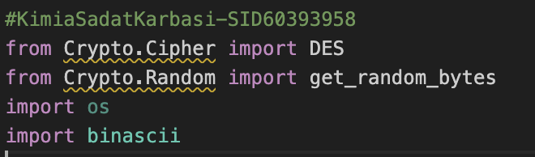
Figure 1 – Importing Libraries

  - File Setup and Reading Input
File paths and encoded text are being defined in a binary format.
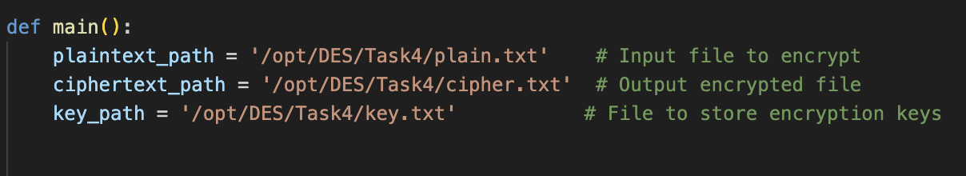
Figure 2 – Reading Input

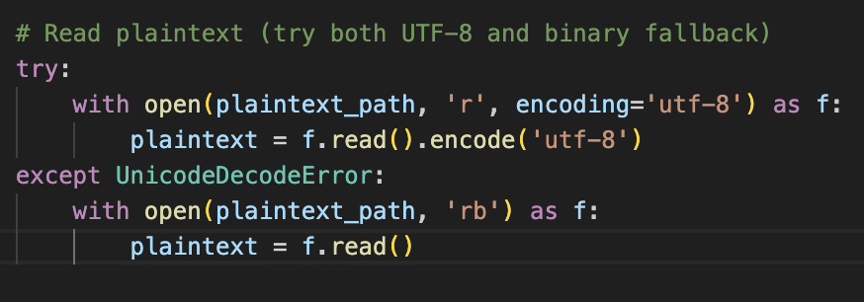
Figure 3 – Encoding Text in binary Format

  - Key/IV Generation
It creates a random 64-bit key and IV
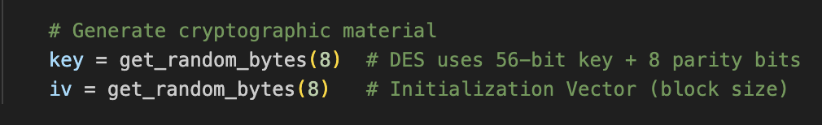

Figure 4 – Key Generation

  - Cipher Setup
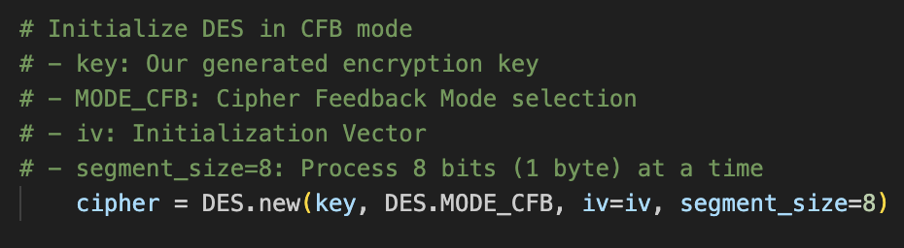
In this step, the configuration for DES in CFB mode will be set.
Figure 5 – Cipher Setup

1.5 Encryption
1.5.1 Encrypts the plain text (Encrypt IV with DES)
1.5.2 XOR result with plaintext
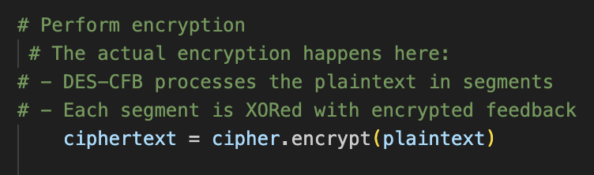
Figure 6 – Encryption of the plain Text

  - Output Handling
    - Convert binary to hex
    - Saving ciphertext and keys in the defined paths
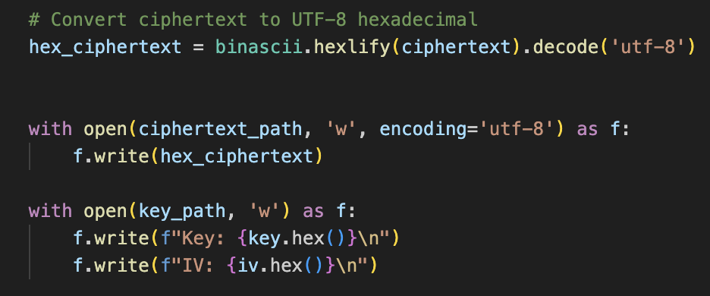
Figure 7 – Output Handing

  - Verification
In this step, encryption details will be printed.

Figure 8 - Encryption Details

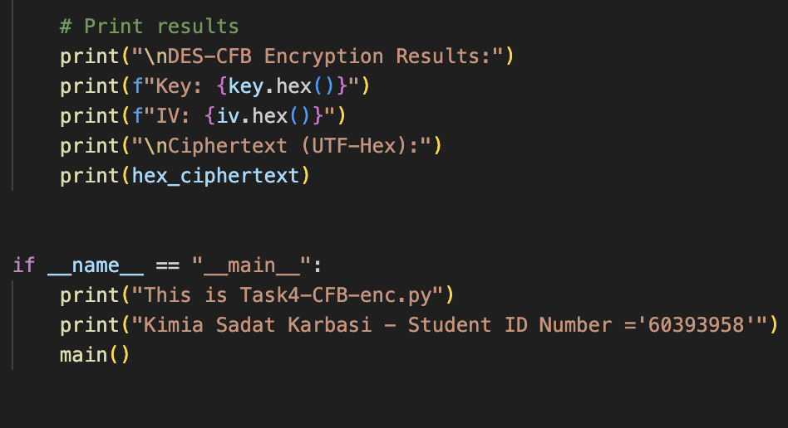
  - Results
Here are all the screenshots of the encryption code executed on a Linux machine. Before executing the Python code, we have to make sure that the library is installed:
sudo pip install pycryptodome

    - Display Output (Key, IV, and Ciphertext)
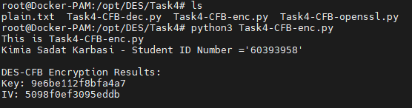

Figure 9 – Output Key
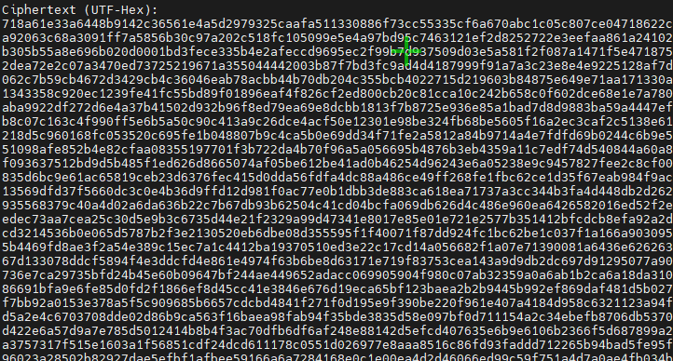

Figure 10 – Output Ciphertext

    - Showing Output from the created file (key.txt and cipher.txt)
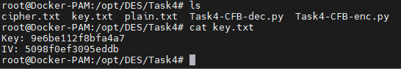
Figure 11 – Key Text

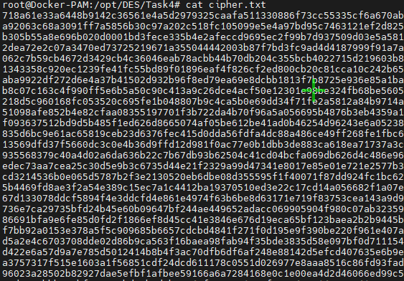
Figure 12 – Cat Cipher Text

This is the part of code that helps to read ciphertext and converts the hex to binary. Details are shown as commands in the code below:
Figure 13 – Reading Ciphertext / Converting Hex to binary

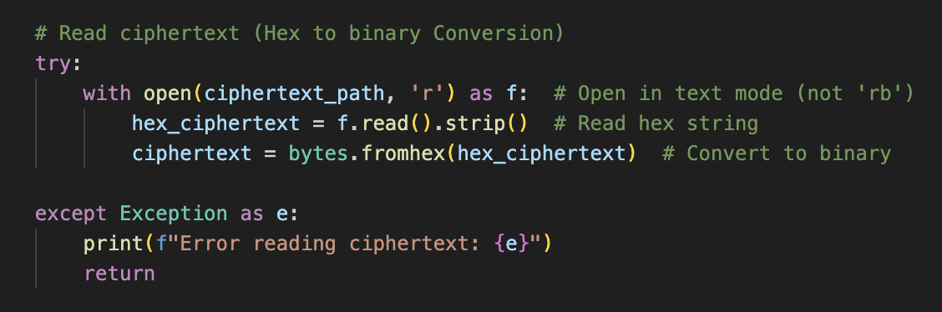
- Decryption Data in CFB Mode
The decryption process is explained step by step in the following section.
2.1 Initialization (PyCryptodome Library)

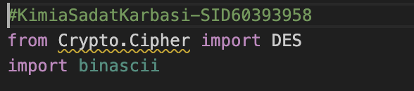

Figure 14 – Importing Library

2.2 File Setup and Reading Inputs
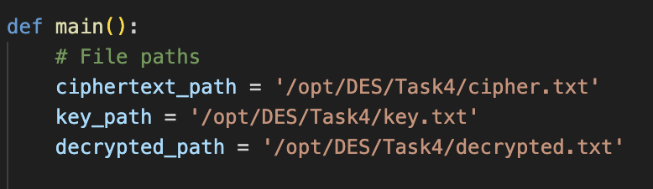
The key, IV, and ciphertext are read and converted to binary.

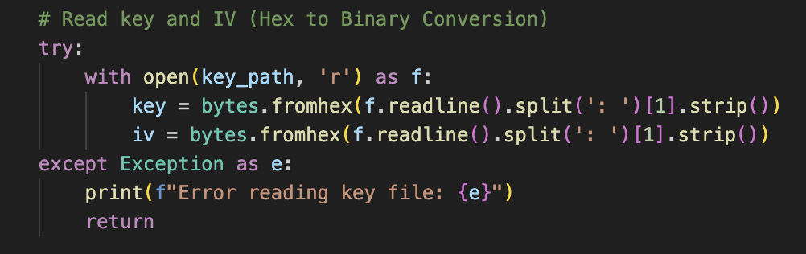
Figure 15 – Reading Inputs

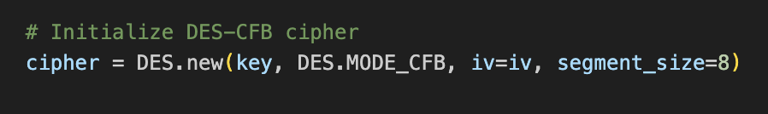
2.3 Cipher Setup
Figure 16 – Cipher Setup

2.4 Decryption
2.4.1 Encrypts the ciphertext (decrypt IV with DES)
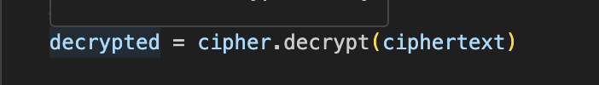
2.4.2 XOR result with ciphertext
Figure 17 – Decrypting Cipher Text

2.5 Output Handling
    - Convert binary to hex
    - Saving ciphertext, keys in the defined paths, and showing them.

Figure 18 – Python Code for Output Handling
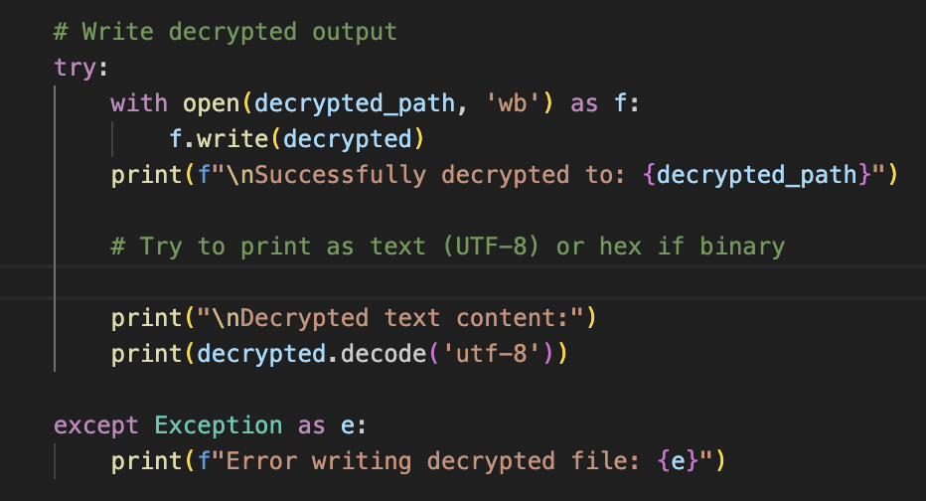
2.6 Results
Here are all the screenshots of the decryption code executed on a Linux machine.

    - Display the decrypted text during the Python code
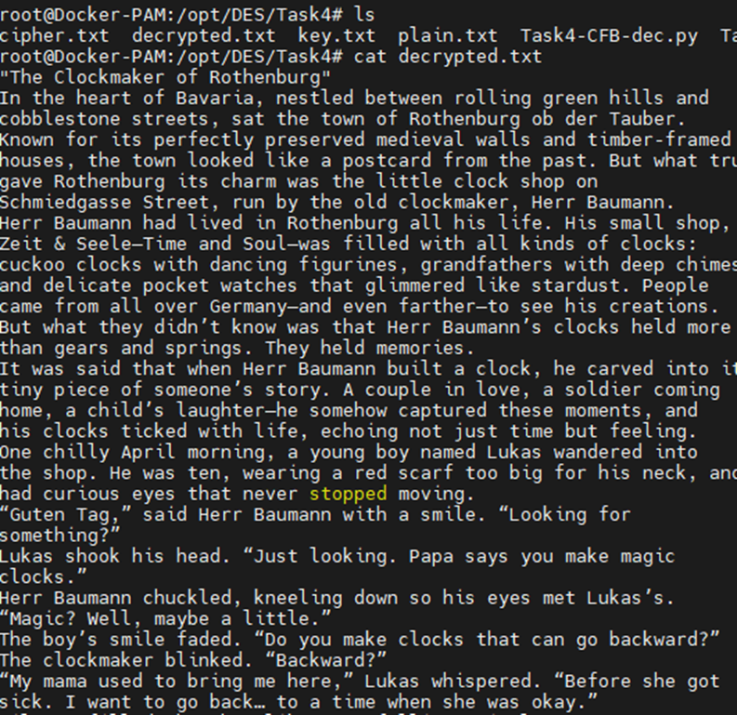Figure 19 - Decrypted text during the Python

    - Output show (decrypted.txt)
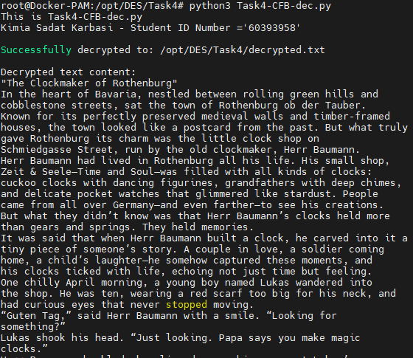
Figure 20 – Decrypted Text output

- Encryption Data with OpenSSL
The Encryption process with OpenSSL is explained step by step in the following section:
3.1 Initialization
Necessary modules are being imported, such as subprocess, used for the OpenSSL command in the Linux machine.
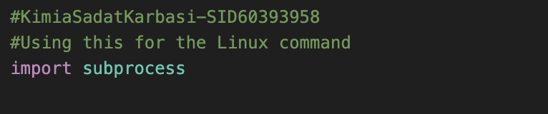
Figure 21- Importing Module

3.2 Encryption with OpenSSL
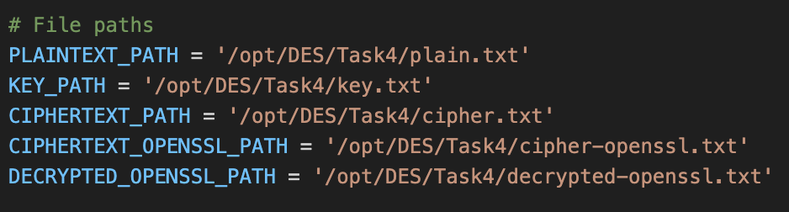
3.2.1 File Setup and Reading Input

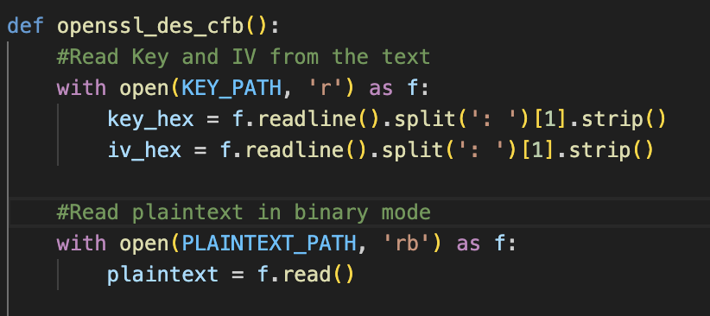
Figure 22 - Reading Inputs and File Setups

3.2.2 Preparing OpenSSL Command and Executing Encryption
Parameters include CFB mode, Key hex, IV Hex, and legacy provider, with high version 3.3 for supporting CFB mode will be used for OpenSSL Command.
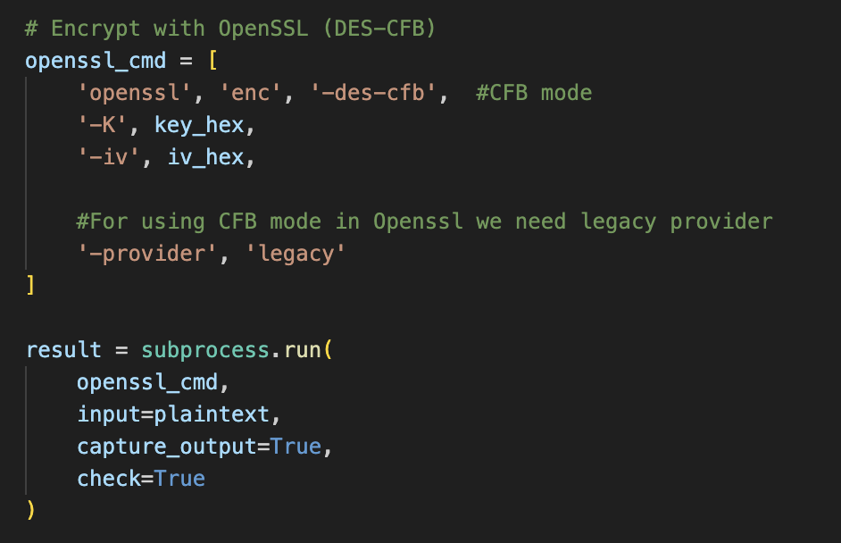

Figure 23 – OpenSSL Command

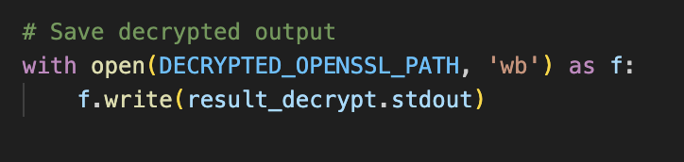
Figure 24 – Decrypted Output

3.3 Decrypt with OpenSSL
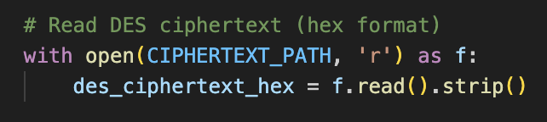
3.3.1 Reading Ciphertext
Figure 25 – Reading Ciphertext

Figure 26 – Decryption with OpenSSL
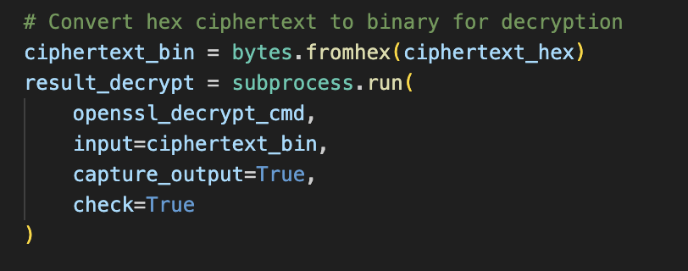
Figure 27 – Converting Cipher Text to Binary

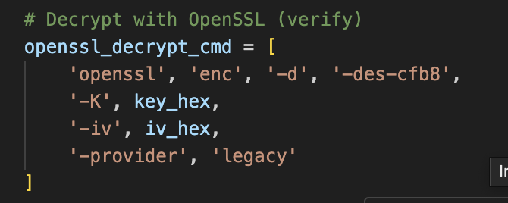

3.5 Output Handling
Display results and verify correctness (Ciphertext match, and Decrypted
matches the original)
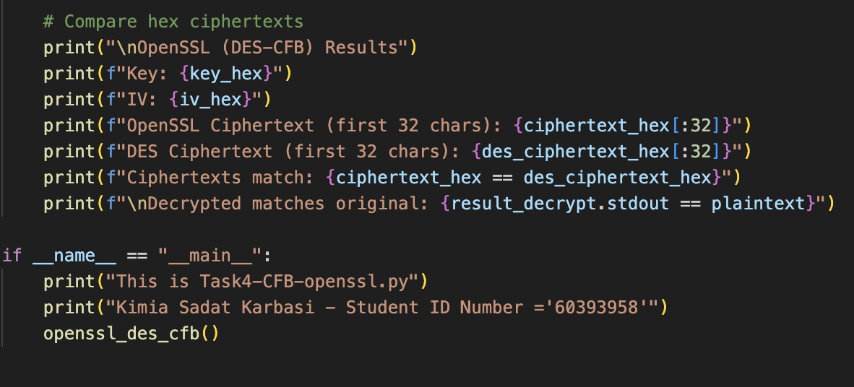
Figure 28 – Displaying Results

  - Results
    - Displaying Details
Details such as key, IV, OpenSSL Cipher text, DES Ciphertext, Matching Ciphertexts, and matching OpenSSL will be decrypted with the original text.
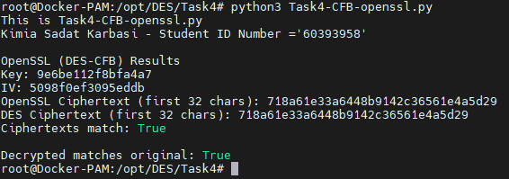
Figure 29 – Results

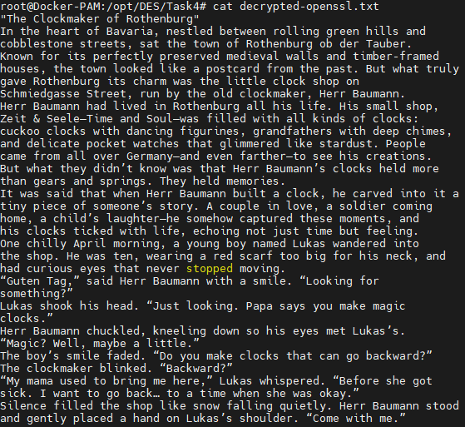
Figure 30 – Decrypted Openssl Text

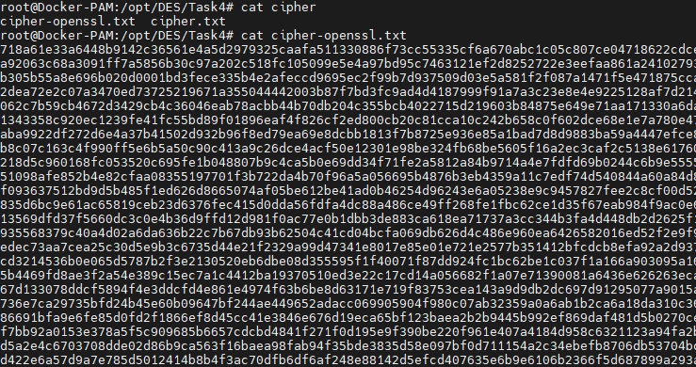

Figure 31 – Cipher Openssl Text

- Comparative analysis
In this phase, we present the comparison between DES-CFB implementation using the PyCryptodome library and OpenSSL's DES-CFB, including a detailed table and explanations.
Now we compare encryption/decryption workflows, Implementation, performance, security, and practical usage of both implementations.
  - Encryption/Decryption Workflow Comparison

Step | Custom DES-CFB | OpenSSL DES-CFB
Key Setup | Read from key.txt (manual parsing) | Read from key.txt (auto parsed)
Encryption | Auto-handled using library | Auto-handled using openssl command
Padding | Manual | Automatic
Output | Save Ciphertext as binary | Save Ciphertext as binary
Decryption | Reverse Process | Single Command (openssl enc)
Error Handling | Manual checks | Built-in

4.2 Implementation & Design

Aspect | Custom DES-CFB | OpenSSL DES-CFB
Codebase | Handwritten (Python) | Precompiled OpenSSL binary
Mode Support | Manual CFB logic | Built-in -des-cfb flag
Providers | - | Requires -provider legacy (v3.0+)

4.3 Performance & Optimization

Aspect | Custom DES-CFB | OpenSSL DES-CFB
Speed | Slower(Python interpreter) | Faster(optimized)
Mode Support | Manual CFB logic | Built-in -des-cfb flag
Hardware acceleration | No | Uses CPU

4.4 Security

Aspect | Custom DES-CFB | OpenSSL DES-CFB
Side-Channel | Vulnerable (lack of constant-time) | Hardened against timing attacks
Padding | Manual handling | Automatic
Maintenance | Your responsibility | Regularly updated

4.5 Practical Use

Aspect | Custom DES-CFB | OpenSSL-CFB
Debugging | Complex | Simple
Portability | Depends on Code | Works everywhere
Command | Using pycryptodome library | openssl enc -des-cfb8
Mode | Testing/Learning | Production

Conclusion

This report shows how to implement DES-CFB encryption by going through four structured phases: data encryption, decryption, OpenSSL integration, and comparative analysis. It was demonstrated during the comparison that OpenSSL’s performance is improved by the use of hardware acceleration and security features.
While our customized implementation was a valuable educational tool for understanding, OpenSSL proved that it can be more efficient and reliable for practical applications.

